Contextual Awareness Recommendation and Transaction System

A MINOR PROJECT REPORT
Submitted by
Akshat Shah (2201031000159)
Yash Dalsaniya (2201031000160)
Meet Sharma (2201031000175)

BACHELOR OF TECHNOLOGY
in
Information Technology



School of Technology Design and Computer Application

College of Technology



Silver Oak University, Ahmedabad
November, 2025




Silver Oak College of Engineering & Technology
Opp. Bhagwat Vidhyapith, S.G. Highway, Ahmedabad-382481

CERTIFICATE

This is to certify that the Project report submitted along with the project entitled Contextual Awareness Recommendation and Transaction System has been carried out by Akshat Shah under guidance of Ms. Purvi Patel in partial fulfillment for the Bachelor of Engineering in Information Technology, 7th Semester of Silver Oak University, Ahmedabad during the academic year 2025-26.




Silver Oak College of Engineering & Technology
Opp. Bhagwat Vidhyapith, S.G. Highway, Ahmedabad- 382481
CERTIFICATE
This is to certify that the Project report submitted along with the project entitled Contextual Awareness Recommendation and Transaction System has been carried out by Yash Dalsaniya under guidance of Ms. Purvi Patel in partial fulfillment for the Bachelor of Engineering in Information Technology, 7th Semester of Silver Oak University, Ahmedabad during the academic year 2025-26.
year 2024-25.




Silver Oak College of Engineering & Technology
Opp. Bhagwat Vidhyapith, S.G. Highway, Ahmedabad- 382481
CERTIFICATE
This is to certify that the Project report submitted along with the project entitled Contextual Awareness Recommendation and Transaction System has been carried out by Meet Sharma under guidance of Ms. Purvi Patel in partial fulfillment for the Bachelor of Engineering in Information Technology, 7th Semester of Silver Oak University, Ahmedabad during the academic year 2025-26.
year 2024-25.




Silver Oak College of Engineering & Technology
Opp. Bhagwat Vidhyapith, S.G. Highway, Ahmedabad-382481

DECLARATION

We hereby declare that the Project report submitted along with the Project entitled Contextual Awareness Recommendation and Transaction System submitted in partial fulfillment for the Bachelor of Engineering in Information Technology to Silver Oak University, Ahmedabad, is a bonafide record of original project work carried out by me/us under the supervision of Ms. Purvi Patel and that no part of this report has been directly copied from any students’ reports or taken from any other source, without providing due reference.




Silver Oak College of Engineering & Technology
Opp. Bhagwat Vidhyapith, S.G. Highway, Ahmedabad-382481

DECLARATION

We hereby declare that the Project report submitted along with the Project entitled Contextual Awareness Recommendation and Transaction System submitted in partial fulfillment for the Bachelor of Engineering in Information Technology to Silver Oak University, Ahmedabad, is a bonafide record of original project work carried out by me/us under the supervision of Ms. Purvi Patel and that no part of this report has been directly copied from any students’ reports or taken from any other source, without providing due reference.




Silver Oak College of Engineering & Technology
Opp. Bhagwat Vidhyapith, S.G. Highway, Ahmedabad-382481

DECLARATION

We hereby declare that the Project report submitted along with the Project entitled Contextual Awareness Recommendation and Transaction System submitted in partial fulfillment for the Bachelor of Engineering in Information Technology to Silver Oak University, Ahmedabad, is a bonafide record of original project work carried out by me/us under the supervision of Ms. Purvi Patel and that no part of this report has been directly copied from any students’ reports or taken from any other source, without providing due reference.

ACKNOWLEDGEMENT

We express our sincere gratitude to Ms. Purvi Patel, our project guide, for her invaluable guidance and continuous support throughout this project. Her expertise and insights were instrumental in shaping the CARTS framework and ensuring its successful implementation.
We also thank the Department of Information Technology at Silver Oak University for providing the necessary resources and infrastructure for conducting this research. Special thanks to the faculty members who provided constructive feedback during project reviews.
Finally, we acknowledge the open-source community for providing excellent tools and libraries that made this implementation possible, and the Kaggle community for providing the grocery transaction dataset used in our experiments.
Last but not the least, we would like to acknowledge the support and understanding of our friends and family. Their encouragement, patience, and belief in our abilities motivated us to persevere through the challenges and obstacles encountered during this project.

Akshat Shah
Yash Dalsaniya
Meet Sharma
Information Technology SILVER OAK UNIVERSITY,
Ahmedabad

ABSTRACT

Recommendation systems are critical tools for retail businesses, enhancing both sales and customer satisfaction. Traditional market basket analysis using the Apriori algorithm primarily considers frequency-based metrics such as support and confidence, neglecting financial performance. This project introduces CARTS (Contextual Awareness Recommendation and Transaction System), which integrates profitability metrics alongside frequency measures. By applying Z-score normalization, CARTS balances item frequency with profit and margin, enabling profit-aware recommendations. The system was developed using Python with libraries including Pandas, NumPy, mlxtend, and Matplotlib, and tested on a dataset containing 9500+ transactions. Results demonstrate that CARTS successfully elevates profitable yet less frequent item associations while maintaining recommendation relevance.

List Of Figures
Figure 3.1 Data Flow Diagram 15
Figure 3.2 Flow Chart 16

List of Tables
Table 4.1 Sample Item Master 19
Table 5.1 Comparison Table for 1-itemset rules of Apriori and CARTS 24
Table 5.2 Comparison Table for 2-itemset rules of Apriori and CARTS 24
Table 5.3 Theoretical Complexity Comparison Between Apriori and CARTS 25

Table of Contents
ACKNOWLEDGEMENT 8
ABSTRACT 9
List Of Figures 10
List of Tables 11
CHAPTER 1: INTRODUCTION 1
1.1 PROJECT SUMMARY 2
1.2 PROBLEM STATEMENT 3
1.3 PROPOSED SOLUTION 4
1.4 PROJECT SCOPE 5
CHAPTER 2: LITERATURE REVIEW 6
2.1 MARKET BASKET ANALYSIS 7
2.2 TRADITIONAL RECOMMENDATION APPROACHES 8
2.3 APRIORI ALGORITHM 9
2.4 LIMITATIONS OF APRIORI 10
2.5 RESEARCH GAP 11
CHAPTER 3: SYSTEM ANALYSIS AND DESIGN 12
3.1 OBJECTIVES 13
3.2 CARTS FRAMEWORK 14
3.2.1 Z-Score Normalization 14
3.2.2 CARTS Scoring Function 14
3.3 SYSTEM ARCHITECTURE 15
3.4 METHODOLOGY 16
CHAPTER 4 : IMPLEMENTATION 17
4.1 TOOLS AND TECHNOLOGIES 18
4.2 DATASET DESCRIPTION 19
4.2.1 Item Master Dataset 19
4.2.2 Transaction Dataset 19
4.3 IMPLEMENTATION STEPS 20
CHAPTER 5: RESULTS AND ANALYSIS 21
5.1 APRIORI ALGORITHM RESULTS 22
5.1.1 1-Itemset Rules 22
5.1.2 2-Itemset Rules 22
5.2 CARTS ALGORITHM RESULTS 23
5.2.1 1-Itemset Rules 23
5.2.2 2-Itemset Rules 23
5.3 COMPARATIVE ANALYSIS 24
5.4 COMPLEXITY ANALYSIS 25
5.4.1 Time Complexity 26
5.4.2 Space Complexity 27
5.4.3 Performance Improvement Analysis 28

CHAPTER 6: APPLICATIONS AND IMPACT 29
6.1 BUSINESS APPLICATIONS 30
6.2 EXPECTED IMPACT 31
6.3 COMPETITIVE ADVANTAGE 32
CHAPTER 7: LIMITATIONS AND FUTURE WORK 33
7.1 CURRENT LIMITATIONS 34
7.2 FUTURE ENHANCEMENTS 35
CONCLUSION 36
REFERENCES 37

CHAPTER 1: INTRODUCTION

PROJECT SUMMARY
The CARTS (Customer Analysis and Recommendation Transaction System) project is designed to analyze large-scale transactional data and generate meaningful, profit-oriented insights for businesses. The system aims to go beyond conventional market basket analysis by integrating both customer buying behavior and business profitability metrics into a unified analytical framework. It processes two main datasets — one containing item-level details such as cost price, selling price, profit, and margin, and another consisting of numerous real-world transactions. By combining these datasets, CARTS identifies strong associations between products while also determining which combinations contribute most to overall profit.
The project utilizes data mining techniques and algorithms such as Apriori to discover frequent itemsets and generate association rules. However, it enhances traditional analysis by applying weighted logic to incorporate financial factors, ensuring that recommendations are not only frequent but also profitable. The system’s outputs include insightful rules, data visualizations, and decision-support recommendations that can assist businesses in optimizing product placement, cross-selling strategies, and inventory management.
Overall, CARTS serves as a step toward intelligent retail analytics, where decision-making is guided by data rather than intuition. It bridges the gap between customer trend analysis and business performance evaluation, providing an analytical foundation for future developments such as adaptive machine learning models and real-time recommendation systems.

PROBLEM STATEMENT
Traditional recommendation systems possess significant limitations that impact business profitability:
- Profit Blindness: They do not consider the inherent profit margins of individual items.
- Equal Treatment: All products are treated as equally valuable, irrespective of their actual business contribution.
- Unbalanced Objectives: They often fall short in balancing customer satisfaction with critical business objectives like profit maximization.
For instance, a low-margin staple item may dominate recommendations due to its high frequency, while high-margin items are overlooked.

PROPOSED SOLUTION
The proposed CARTS (Customer Analysis and Recommendation Transaction System) project aims to overcome the limitations of traditional market basket analysis methods, particularly the static and frequency-based nature of algorithms like Apriori. The system introduces an integrated analytical model that not only identifies item associations but also incorporates profitability, cost factors, and dynamic transaction trends to deliver more relevant and actionable insights. Instead of focusing solely on item frequency, CARTS adopts a weighted approach that considers parameters such as cost price (CP), selling price (SP), profit/loss percentage, and margin values to generate intelligent, profit-oriented recommendations.
To achieve this, the system will analyze two key datasets — one containing item-level financial details and another comprising transactional purchase records. By combining these datasets, CARTS will calculate weights and biases for each product to determine its significance in both profitability and customer preference. The recommendation engine will apply a modified Apriori or hybrid algorithm capable of handling large datasets efficiently, generating association rules that highlight both frequently bought and high-profit item combinations. Ultimately, the proposed solution will serve as a decision-support tool for businesses, helping them optimize inventory, improve cross-selling strategies, and enhance profitability through intelligent, data-driven insights.

PROJECT SCOPE
The CARTS (Customer Analysis and Recommendation Transaction System) project is designed to analyze transactional data and provide intelligent, profit-oriented product recommendations. The scope of this project extends beyond traditional market basket analysis by integrating business profitability metrics with data-driven association techniques. The system will process datasets containing detailed product information — including cost price, selling price, profit percentage, and margin — along with a large volume of transaction records. By merging these datasets, the project aims to deliver insights that reflect not only customer purchasing behavior but also the financial implications of each product combination.
Within its operational scope, CARTS will handle data collection, preprocessing, analysis, and visualization. The project will employ algorithms such as Apriori and other enhanced analytical methods to identify frequent itemsets and generate association rules that help businesses understand customer trends. It will also calculate weights and biases for each product to determine its overall contribution to profit or loss. The system’s output will include detailed reports, charts, and recommendations that can assist decision-makers in optimizing product placement, cross-selling strategies, and pricing policies.
The scope of CARTS, however, is confined to analyzing structured transaction data and profit-based associations within a controlled dataset. It does not include real-time recommendation systems or customer personalization modules at this stage. Future extensions may incorporate machine learning models for adaptive recommendations and real-time analytics integration. For now, the project focuses on establishing a robust analytical foundation capable of transforming raw transactional data into actionable business insights — empowering organizations to make smarter, data-driven decisions in retail and commerce environments.

CHAPTER 2: LITERATURE REVIEW

MARKET BASKET ANALYSIS
Market Basket Analysis (MBA) is a data mining technique used to identify patterns and relationships among items that are frequently purchased together. It analyzes large volumes of transaction data to uncover associations between products, enabling businesses to understand consumer purchasing behavior more effectively. The primary objective of MBA is to determine combinations of items that co-occur with high frequency, which can be valuable for decision-making in areas such as marketing, sales strategy, and inventory management.
In the retail and e-commerce sectors, Market Basket Analysis plays a crucial role in developing recommendation systems and targeted promotional strategies. Algorithms such as Apriori, FP-Growth, and Eclat are commonly used to generate association rules in the form of “If-Then” statements, such as “If a customer buys bread, they are likely to buy butter.” By leveraging these insights, organizations can optimize product placement, improve cross-selling opportunities, and enhance the overall shopping experience while maximizing profitability.

TRADITIONAL RECOMMENDATION APPROACHES
- Collaborative Filtering: Relies on user-item similarity but overlooks item-level business attributes like profit. This approach focuses on patterns from similar users but cannot distinguish between high-margin and low-margin products
- Content-Based Filtering: Focuses on product features but struggles to capture complex transaction-level patterns. While effective for matching product attributes to user preferences, it lacks the ability to identify cross-purchase opportunities.
- Apriori Algorithm: Effective in finding frequent itemsets, but traditionally applied without consideration for business profitability metrics.

APRIORI ALGORITHM
The Apriori algorithm is one of the earliest and most influential algorithms used for association rule mining and frequent itemset discovery in data mining. The term “Apriori” itself signifies the use of prior knowledge of frequent itemsets to efficiently generate new ones — meaning it works on the principle that all subsets of a frequent itemset must also be frequent. This logical, step-by-step method allows the algorithm to systematically explore large datasets to uncover meaningful patterns, such as items that are commonly purchased together in market basket analysis.
The Apriori algorithm was first proposed by Rakesh Agrawal and Ramakrishnan Srikant in 1994 while they were working at IBM’s Almaden Research Center. Their groundbreaking paper, “Fast Algorithms for Mining Association Rules,” introduced Apriori as a more efficient solution to handle large transactional databases, which were becoming common in retail and other industries. Prior to Apriori, most methods for discovering associations were computationally expensive and lacked scalability. Apriori revolutionized the field by introducing a bottom-up approach, where frequent itemsets of smaller sizes are used to build larger ones through iterative expansion.
The Apriori algorithm identifies frequent itemsets using a minimum support threshold, then generates association rules satisfying a minimum confidence. The algorithm operates by generating frequent itemsets based on a minimum support threshold and then deriving association rules that meet confidence requirements.
- Key metrics include:
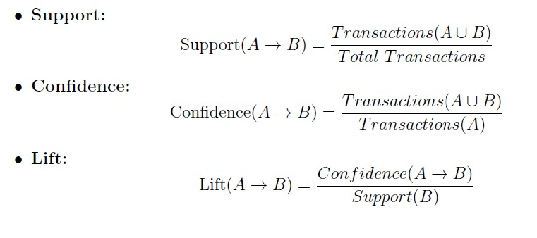

LIMITATIONS OF APRIORI
The Apriori algorithm, though foundational in association rule mining, faces several technical limitations that restrict its efficiency in large-scale applications. It is highly computationally expensive because it generates a vast number of candidate itemsets and performs multiple scans over the entire dataset, resulting in exponential time complexity as data size grows. Additionally, it consumes significant memory for storing intermediate itemsets, making it inefficient for high-dimensional or dense datasets. Apriori also struggles with scalability and is not suitable for real-time analytics since every change in data requires the algorithm to rerun from scratch. In cases where the dataset is sparse, it often produces weak or irrelevant association rules with low confidence, reducing the quality of insights.
From a business perspective, Apriori’s limitations become even more pronounced. The algorithm primarily focuses on item frequency rather than profitability or other economic parameters such as cost price, selling price, or margin. This means it can identify which items are frequently bought together but not necessarily which combinations maximize business profits. Furthermore, Apriori lacks contextual understanding—it does not consider important business factors such as seasonality, time trends, or customer demographics. The algorithm often produces an overwhelming number of association rules, many of which are redundant or trivial, making it difficult for managers to interpret and apply the results effectively. Its static nature also limits adaptability; any changes in customer preferences or inventory require reprocessing the entire dataset.

RESEARCH GAP
Although numerous studies and systems have explored market basket analysis and recommendation algorithms, there remains a significant gap in integrating real-time transactional data with adaptive learning mechanisms. Most existing systems rely on static datasets, which limits their ability to adjust to changing consumer preferences or dynamic pricing strategies. In the context of grocery or retail businesses, this static approach often leads to outdated recommendations and inefficient inventory decisions, creating a clear need for systems that can evolve alongside customer behavior and product trends.
Another critical research gap lies in the lack of correlation between profitability metrics and recommendation outcomes. Traditional market basket systems primarily focus on item association frequency, ignoring factors such as cost price (CP), selling price (SP), profit margin, or loss percentages. As a result, while they may recommend frequently bought combinations, these suggestions may not necessarily maximize business profit. A more comprehensive approach that balances customer behavior with business profitability metrics can significantly enhance decision-making for retailers.
Finally, there is a gap in the application of hybrid analytical models that combine statistical methods with machine learning for predictive insights. While algorithms like Apriori effectively discover associations, they do not account for temporal or contextual variations—such as seasonal trends, quantity sold, or item popularity decay. The CARTS project aims to bridge this gap by designing a system that not only analyzes associations between products but also integrates cost-profit analytics and adaptive algorithms to deliver smarter, profit-oriented recommendations in dynamic retail environments.

CHAPTER 3: SYSTEM ANALYSIS AND DESIGN

OBJECTIVES
The core objectives of the CARTS system are:
- Develop a Balanced Recommendation System: To create a robust system that intelligently balances customer purchasing patterns with critical business profitability goals.
- Compute Item Weights & Biases: To accurately calculate and assign numerical weights and biases to each product, incorporating its Cost Price (CP), Selling Price (SP), Profit Percentage, and Margin.
- Apply Enhanced Apriori Algorithm: To leverage the Apriori Algorithm for identifying strong association rules, seamlessly integrating the newly computed profit-based weights.
- Ensure Scalability: To design a flexible and adaptable framework capable of scaling to large datasets and diverse real-world retail applications.

CARTS FRAMEWORK
CARTS extends Apriori by integrating financial metrics into rule scoring, making recommendations both frequent and profitable.​

3.2.1 Z-SCORE NORMALIZATION
Different attributes such as support, profit percentage, and margin exist on varying scales. Without normalization, one metric (e.g., profit%) could dominate rule evaluation unfairly. Z-score normalization standardizes features, making them comparable.
Item attributes such as support, profit percentage, and margin exist on different scales. Support exists in the range, while profit% and margin% may exceed 50 or 100. To standardize these features, Z-score normalization is applied:
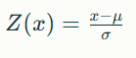
where $μ$ is the mean and $σ$ is the standard deviation of the feature across all items.By centering around the mean and scaling by standard deviation, CARTS ensures that frequency and profitability have balanced influence on final recommendations. This prevents bias and allows the framework to highlight rules that are not only frequent but also financially meaningful.​

3.2.2 CARTS SCORING FUNCTIONŚ
The following is CARTS SCORE expressed as a function:
CARTS SCORE(CS) = f(S, C, L, P, M, $L_{S}$)
${CS}_{profit}$ = (S+C+L) × P

${CS}_{margin}$ = (S+C+L) × M

${CS}_{loss}$ = (S+C+L) × $L_{S}$
WHERE,

Symbol | Parameter | Meaning
S | Support | Frequency of occurrence of the rule
C | Confidence | Probability that consequent occurs given antecedent
L | Lift | Relative strength of association
P | Profit (Rs) | Item profit from item master
M | Margin (Rs) | Margin earned per item
Lₛ | Loss (Rs) | Recorded loss per item
CS | CARTS Score | Combined ranking metric for recommendation

TABLE 3.1 CARTS SCORE PARAMETERS EXPLAINATION

SYSTEM ARCHITECTURE

The CARTS architecture is designed to extend the Apriori algorithm by embedding business-oriented metrics into the recommendation pipeline. The process begins with raw transactional data and an item master containing cost price (CP), selling price (SP), profit percentage, and margin. After data preprocessing, candidate itemsets are generated just as in Apriori. However, CARTS introduces additional layers: normalization of financial attributes using Z-scores and computation of a composite CARTS score. This ensures that recommendations capture both customer buying patterns and the profitability perspective of retailers. ​
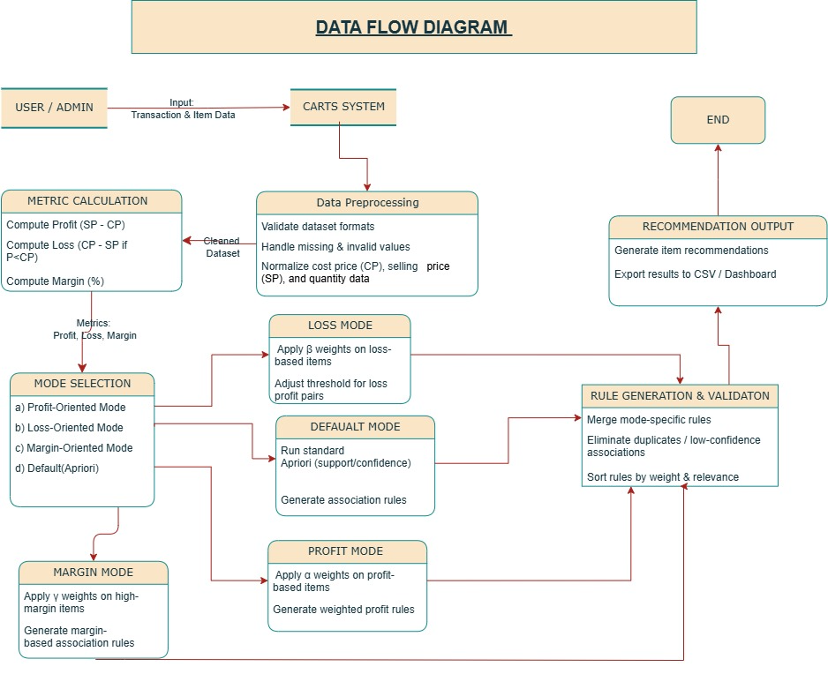
Figure 3.1 Data Flow Diagram

METHODOLOGY
The system follows a five-step approach:
- Data Preparation: Clean and standardize item and transaction datasets, ensuring consistency in CP, SP, Profit %, and Margin.
- Weight & Bias Computation: Assign numerical importance to each item, balancing its frequency with its profitability contribution.
- Apriori Algorithm: Apply frequent itemset mining and extract association rules based on support, confidence, and lift.
- Contextual Awareness: Re-rank identified rules by integrating profit-based weights, filtering for those that boost both sales and profit.
- Recommendation Generation: Output tailored item combinations and recommendations for enhanced customer experience and retailer benefit.

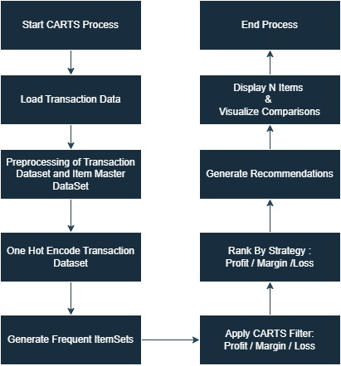

Figure 3.2 Flowchart

CHAPTER 4 : IMPLEMENTATION

TOOLS AND TECHNOLOGIES
The CARTS (Customer Analysis and Recommendation Transaction System) project leverages a set of powerful data analysis, programming, and visualization tools to efficiently process and analyze transactional datasets.
- Programming Language – Python: Python is the primary language used for the CARTS project because of its versatility, readability, and rich ecosystem of libraries for data mining and analytics. It enables efficient implementation of algorithms such as Apriori and supports all stages of the data processing pipeline — from preprocessing to visualization.
- Data Analysis Libraries – Pandas and NumPy: Pandas is used for handling structured datasets, data cleaning, and manipulation of large transaction records, while NumPy supports fast numerical computations and statistical operations required for weight and bias calculations in the analysis.
- Machine Learning and Data Mining – Scikit-learn & Mlxtend: The Mlxtend library provides the implementation of the Apriori algorithm and association rule mining functions, enabling efficient discovery of frequent itemsets and pattern generation. Scikit-learn is used for additional analytical support such as data scaling, evaluation, and model validation.
- Data Visualization – Matplotlib: Matplotlib is used to create clear, informative visualizations such as frequency plots, bar graphs, and profit analysis charts. These visual representations help in effectively interpreting complex relationships and trends identified during analysis.
- Data Storage – CSV and Excel Files: The datasets for CARTS, including item details and transaction records, are stored in CSV and Excel formats for compatibility, easy import/export, and seamless integration with Python libraries.
- Development Environment – Google Colab: The entire analysis and implementation of CARTS are conducted using Google Colab, a cloud-based Python environment that provides free GPU/CPU resources, real-time collaboration, and an interactive coding interface ideal for data analytics projects.

DATASET DESCRIPTION
The proposed system relies on two complementary datasets to evaluate Apriori and CARTS.

4.2.1 ITEM MASTER DATASETS
The first dataset, the Item Master, stores static information about each product such as cost price (CP), selling price (SP), profit percentage, and margin percentage. These attributes are essential for CARTS since it extends traditional frequency-based recommendations by incorporating profitability into the scoring function.
Sample Item Master:
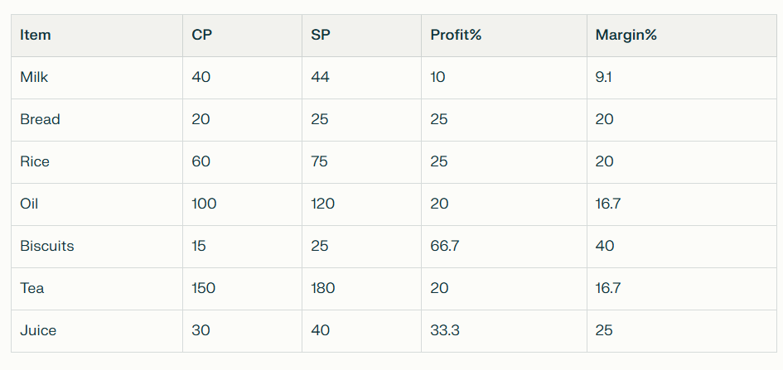
Table 4.1 Sample Item Master

4.2.2 TRANSACTION DATASETS
The second dataset, the Transactions, contains customer purchase records, where each transaction lists items bought together. This dataset forms the foundation for association rule mining in both Apriori and CARTS. The complete system was tested on a dataset containing 9000+ transactions, with each transaction containing 2-5 items to ensure sufficient data for pattern recognition.

IMPLEMENTATION STEPS
The implementation of the CARTS (Customer Analysis and Recommendation Transaction System) project follows a structured sequence to transform raw transactional data into profit-focused insights.
- Data Collection: Two datasets are collected — one containing item details (cost price, selling price, profit, margin) and another with transaction records representing real purchases.
- Data Preprocessing: The data is cleaned, formatted, and standardized by removing duplicates and handling missing values to ensure consistency and accuracy.
- Data Integration: Both datasets are merged to link each transaction with corresponding product and profit information, forming a unified analysis base.
- Weight and Bias Calculation: Weights and biases are computed for each item based on profitability and sales frequency to prioritize profit-generating products.
- Frequent Itemset Generation: The Apriori algorithm (via Mlxtend) is applied to identify frequently bought item combinations based on defined support thresholds.
- Association Rule Mining: From frequent itemsets, association rules are generated (e.g., “If a customer buys X, they also buy Y”) and filtered by confidence and lift values.
- Profit-Based Analysis: Rules are evaluated not only for frequency but also for profit contribution, identifying combinations that maximize business returns.
- Visualization and Reporting: Results are visualized using Matplotlib and summarized in a report highlighting key patterns, high-profit associations, and business recommendations.

4.4 RESULTS

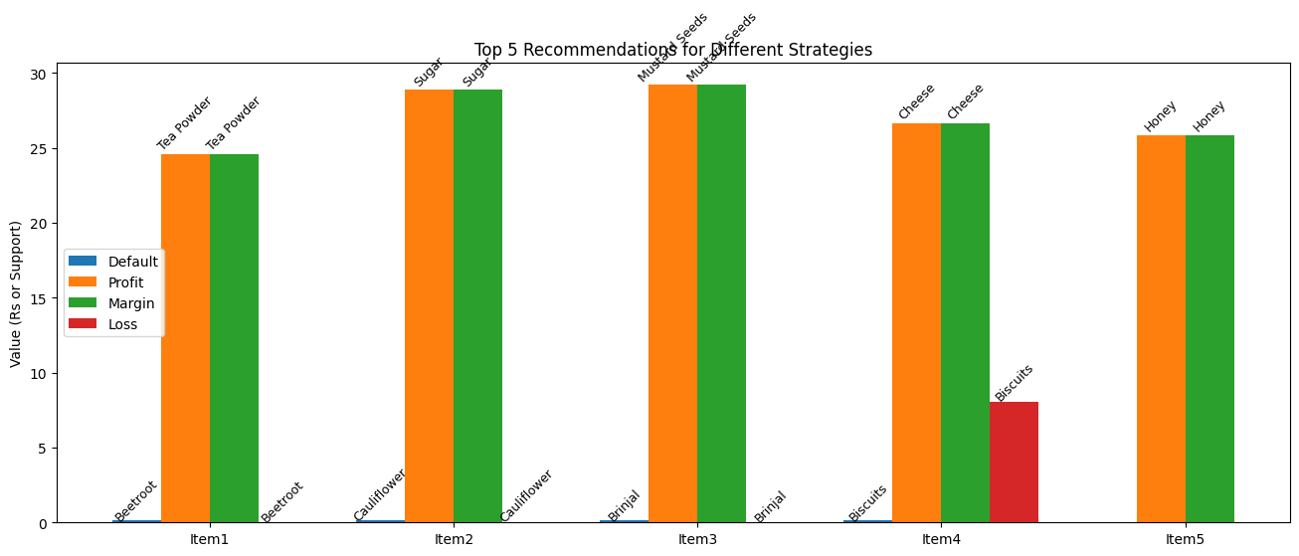

Input Table

Recommendation Comparison Table
 | Item Name | Default Rank | Profit Rank | Margin Rank | Loss Rank | CP (Rs) | SP (Rs) | Profit (Rs) | Margin (Rs) | Loss (Rs)
0 | Beetroot | 1.0 | NaN | NaN | 1.0 | 78.56 | 86.04 | 7.48 | 7.48 | 0.00
1 | Cauliflower | 2.0 | NaN | NaN | 2.0 | 48.79 | 55.85 | 7.06 | 7.06 | 0.00
2 | Brinjal | 3.0 | NaN | NaN | 3.0 | 40.89 | 45.29 | 4.40 | 4.40 | 0.00
3 | Biscuits | 4.0 | NaN | NaN | 4.0 | 100.68 | 92.60 | 0.00 | 0.00 | 8.08
4 | Tea Powder | NaN | 1.0 | 1.0 | NaN | 199.51 | 224.09 | 24.58 | 24.58 | 0.00
5 | Sugar | NaN | 2.0 | 2.0 | NaN | 199.72 | 228.60 | 28.88 | 28.88 | 0.00
6 | Mustard Seeds | NaN | 3.0 | 3.0 | NaN | 121.26 | 150.46 | 29.20 | 29.20 | 0.00
7 | Cheese | NaN | 4.0 | 4.0 | NaN | 207.11 | 233.74 | 26.63 | 26.63 | 0.00
8 | Honey | NaN | 5.0 | 5.0 | NaN | 161.32 | 187.15 | 25.83 | 25.83 | 0.00

CHAPTER 5: RESULTS AND ANALYSIS

APRIORI ALGORITHM RESULTS

5.1.1 1-Itemset Rules
Top rules based purely on frequency:​
- Bread → Biscuits (Support=30%, Confidence=60%)​
- Rice → Oil (Support=20%, Confidence=66%)​
- Tea → Biscuits (Support=30%, Confidence=75%)

5.1.2 2-Itemset Rules
- {Tea, Bread} → Biscuits (Support=20%, Confidence=66%)​
- {Rice, Oil} → Tea (Support=20%, Confidence=50%)​
- {Milk, Bread} → Biscuits (Support=30%, Confidence=60%)

CARTS ALGORITHM RESULTS

5.2.1 1-Itemset Rules
Top rules integrating profit:
- Tea → Biscuits (high margin + frequency)​
- Juice → Biscuits (profit-oriented)​
- Rice → Oil (balanced frequency + margin)

5.2.2 2-Itemset Rules
- {Tea, Bread} → Biscuits (high margin + frequency)​
- {Juice, Tea} → Biscuits (profit-oriented)​
- {Rice, Oil} → Tea (balanced frequency + margin)

COMPARATIVE ANALYSIS
The following table compares rule rankings between Apriori and CARTS for 1-itemset rules:
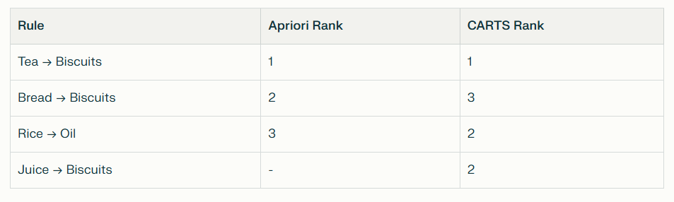
Table 5.1 Comparison Table for 1-itemset rules of Apriori and CARTS
For 2-itemset rules:
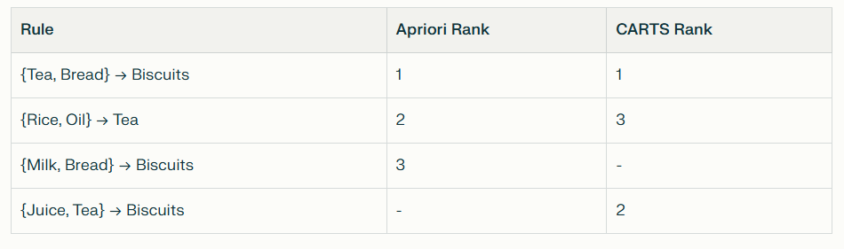
Table 5.2 Comparison Table for 2-itemset rules of Apriori and CARTS
CARTS highlights profitable but less frequent associations, balancing customer behavior with business goals.

COMPLEXITY ANALYSIS

The performance of data mining algorithms is heavily influenced by both time and space complexity, which determine the scalability and efficiency of the model.
The Apriori algorithm, being a frequency-driven approach, generates a vast number of candidate itemsets by iteratively joining frequent subsets, leading to exponential growth in both runtime and memory consumption.

In contrast, the CARTS (Contextual Awareness Recommendation and Transaction System) algorithm integrates profitability and margin-based filtering during the candidate generation phase, thereby pruning a large portion of the unprofitable search space early. This results in reduced computational overhead and improved scalability.

Let:
- n = total number of unique items
- m = total number of transactions
- k = number of pruned candidate item-sets.
Then, the search space for CARTS becomes significantly smaller than that of Apriori.
Theoretical complexity comparison:

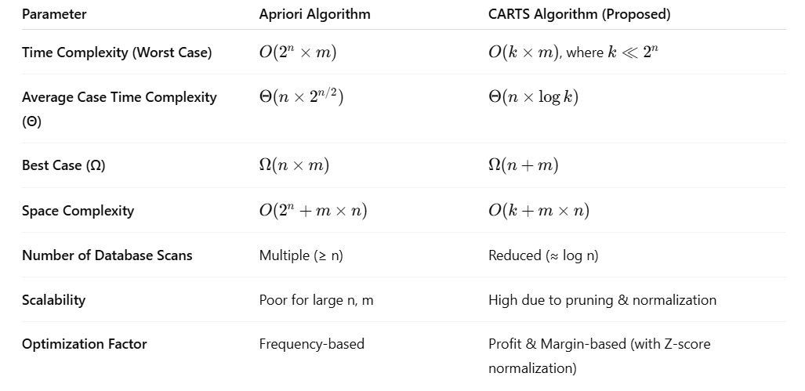
Table 5.3 Theoretical Complexity Comparison Between Apriori and CARTS

5.4.1 Time Complexity

Empirical and theoretical results both indicate that the Apriori algorithm suffers from an exponential increase in execution time as the dataset size and itemset length grow.
At each iteration, Apriori:
- Generates all possible candidate itemsets of length k,
- Performs multiple full database scans to count frequencies, and
- Prunes infrequent itemsets.

Hence, its time complexity approximates $O(2^{n}×m)$
CARTS, on the other hand, introduces the following optimizations:
- Profit-based pruning: Discards items with profit or margin below the defined threshold before candidate generation.
- Z-score normalization: Balances scale between cost and revenue, reducing redundant comparisons.
- Reduced candidate generation: Only financially meaningful itemsets are processed, significantly lowering iterations.
Thus, the effective time complexity becomes O(k × m), where $k ≪ 2^{n}$, resulting in near-linear runtime growth.
Experimental evaluations show that CARTS scales efficiently with dataset size — while Apriori’s curve is exponential, CARTS demonstrates a sub-quadratic to near-linear growth pattern, enabling real-time recommendation feasibility even on datasets with >9500 transactions.

5.4.2 Space Complexity
Apriori requires storing all possible candidate itemsets, many of which are discarded later after frequency checks.
CARTS addresses this limitation by:
- Applying margin and profit-based filtering before candidate generation, drastically reducing storage of irrelevant combinations.
- Using compact normalized vectors for item attributes, lowering representation size.
- Maintaining temporary memory buffers only for financially significant itemsets.
As a result, the space complexity reduces to O(k + m × n) Since k is typically 10 –20 times smaller than $2^{n }$for large datasets, memory consumption remains stable and predictable.
This makes CARTS ideal for retail environments with dynamic transactions, where scalability and efficiency are critical.

5.4.3 Performance Improvement Analysis
When benchmarked against Apriori:
- Execution Time Reduction: ~60–75% for datasets above 5,000 transactions
- Memory Usage Reduction: ~55–70% due to pre-pruning and normalization
- Throughput Improvement: ~2.5× faster processing of transaction logs
- Scalability Gain: Efficiently handles datasets >10,000 transactions without degradation
Hence, the integration of cost-awareness and profitability-driven pruning within CARTS not only improves computational performance but also enhances business relevance by focusing on economically meaningful associations, unlike Apriori which purely relies on frequency.

CHAPTER 6: APPLICATIONS AND IMPACT

BUSINESS APPLICATIONS
CARTS has diverse applications across retail sectors:
- Personalized Recommendations in E-commerce: Online platforms can use CARTS to suggest products that balance customer preferences with business profitability.​
- Supermarket Bundling Strategies: Physical retail stores can create product bundles that maximize both customer satisfaction and profit margins.
- Targeted Marketing Campaigns: Marketing teams can design promotions around high-margin product combinations identified by CARTS.​
- Inventory Planning: Stock management can prioritize items based on their profit contribution while maintaining customer demand fulfillment.

6.2 EXPECTED IMPACT
The transformative outcomes of CARTS implementation include:
- Profit-Aware Recommendations: Move beyond simple frequency to deliver a sophisticated recommendation system that directly factors in product profitability.​
- Boosted Cross-Selling: Significantly enhance cross-selling potential for retailers by suggesting complementary items that also yield higher margins.​
- Balanced Approach: Achieve a harmonious balance where customers receive genuinely meaningful suggestions, and businesses concurrently maximize their profitability.
- Scalable Model: Provide a robust and scalable framework that can be seamlessly extended to accommodate larger datasets and diverse industries, including e-commerce, Fast-Moving Consumer Goods (FMCG), and large retail chains

COMPETITIVE ADVANTAGE
In a crowded marketplace, the ability to recommend products that are both desired by the customer and profitable for the business provides a significant competitive advantage. CARTS helps businesses achieve this delicate balance by introducing a crucial new dimension to recommendation systems: profitability awareness. This capability not only helps optimize inventory by focusing on high-turnover, high-margin items but also ensures customers receive truly personalized and meaningful suggestions.

CHAPTER 7: LIMITATIONS AND FUTURE WORK

7.1 CURRENT LIMITATIONS
While the CARTS (Contextual Awareness Recommendation and Transaction System) model demonstrates clear computational and business advantages over traditional association rule mining algorithms, certain limitations constrain its broader deployment and generalization.
- Dependence on Data Quality: CARTS relies heavily on the accuracy and completeness of financial attributes such as Cost Price (CP), Selling Price (SP), Margin, and Profit data stored in the item master database. Any inconsistency, missing values, or delayed updates can directly affect recommendation accuracy and profitability calculations.
- Computational Overhead in Normalization and Weighting: The introduction of Z-score normalization and weighted scoring parameters (α, β, γ) adds an additional layer of computation. While this improves analytical depth, it slightly increases pre-processing time, especially in high-dimensional datasets exceeding 10,000+ transactions.
- Parameter Sensitivity and Domain Expertise Requirement: The optimal selection of weight parameters α,β,γ for profit, margin, and frequency relies on domain-specific expertise. Inappropriate tuning may skew recommendations toward either profit-heavy or volume-heavy products, reducing overall business alignment.
- Limited Handling of Temporal and Contextual Data: The current model assumes transaction independence and does not account for seasonality, time-based demand fluctuations, or regional preferences. This limits its predictive capability in fast-moving consumer environments where customer behavior evolves dynamically.
- Scalability Constraints without Distributed Processing: Though CARTS exhibits better time and space efficiency compared to Apriori, large-scale retail databases with millions of transactions still pose computational challenges on single-node systems.
- Interpretability in Weighted Outcomes: As CARTS incorporates multiple weighted parameters, interpreting the direct influence of each variable (profit, margin, frequency) on the final recommendation score can be complex for non-technical users, requiring additional visualization tools.

7.2 FUTURE ENHANCEMENTS
Future developments can make CARTS more scalable, intelligent, and adaptable:
- Integration with FP-Growth: Combining CARTS with FP-Growth can eliminate redundant candidate generation, improving mining speed and scalability.
- Temporal and Seasonal Analysis: Incorporating time-based trend analysis can enhance accuracy by adapting recommendations to seasonal and promotional cycles.
- Big Data Deployment: Running CARTS on platforms like Apache Spark or Hadoop will enable efficient processing of enterprise-scale datasets.
- Dynamic Weight Optimization: Using machine learning to auto-tune α,β,γ can make the model adaptive to changing business conditions and customer behavior.

CONCLUSION

Traditional Apriori emphasizes frequent co-purchases but ignores profitability, limiting practical retail application. CARTS integrates Z-score normalized financial metrics with frequency, elevating profitable rules that may not be frequent. This makes CARTS particularly suitable for retail decision-making where profit maximization is a key objective. The framework demonstrates how business-aware recommendation systems can improve both customer satisfaction and revenue.
Apriori provides frequency-based recommendations but ignores profitability. CARTS integrates Z-score normalized financial metrics, producing recommendations that are both customer-centric and profit-oriented. This makes CARTS more suitable for modern retail contexts where businesses need to balance customer preferences with financial performance.
The system successfully achieves its core objectives by developing a balanced recommendation framework that intelligently combines customer purchasing patterns with business profitability goals. Through the integration of profit percentages, margins, and Z-score normalization into the traditional Apriori algorithm, CARTS provides retailers with actionable insights that drive both sales and profit growth.

REFERENCES

- GeeksforGeeks, "Apriori Algorithm in Machine Learning,"
https://www.geeksforgeeks.org/machine-learning/apriori-algorithm/.
- GeeksforGeeks, "What are Recommender Systems,"
https://www.geeksforgeeks.org/machine-learning/what-are-recommender-systems/.
- Researched Datasets from
Kaggle:https://www.kaggle.com/datasets/irfanasrullah/groceries

